***Computer Components***

**Figure 2.1: A Computer System (PC)**

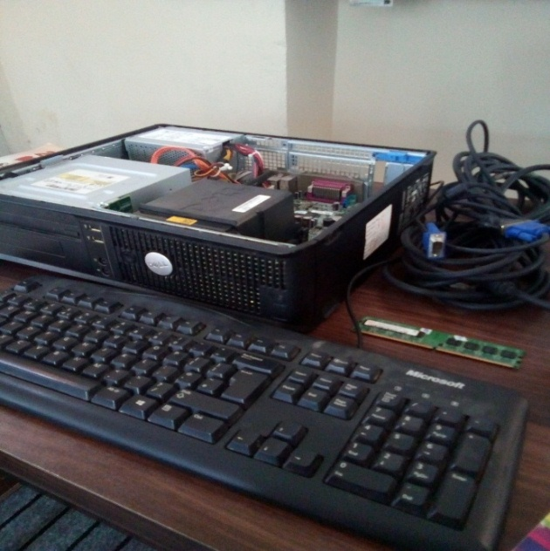

A computer is a device that accepts data and processes if for some result based on a sequences of instructions. The sequences of instructions given to computer for manipulating data is known as a **program.**

**2.1 Components of Computer System**

There are two basic components of a computer system.

* **Computer Hardware.**

**2.1.1 Computer Hardware**

The physical parts of the computer system that you can touch and feel are known as ***computer hardware.*** In a broader sense a computer can be divided into following hardware units.

* Input Unit
* Output Unit
* System Unit
* **INPUT UNIT**

Input unit of a computer system consists of input devices. Due to the diverse nature of the data, variety of input devises exist to input data in different forms e.g. keyboard is used to enter textual data, mouse is used as a pointing device and to trigger different commands in different applications.

* **OUTPUT UNIT**

Output unit of a computer system consists of output devise. As data presented to the user can take variety of forms, therefore different output devices are needed e.g. monitor used to display text and images on a screen, printer is used to get output on paper; speaker used to review voice output etc.

* **SYSTEM UNIT**

System unit contains a number of other components which are enclosed in a rectangular casing. The casing is available in two different shapes i.e. vertical shape (called tower casing) and horizontal shape (called desktop casing). The most important component of systems unit is a rigid rectangular circuit board called **motherboard**.